Cardiorespiratory Endurance
Ability for your heart, lungs and muscles to work aerobically over an extended period of time.
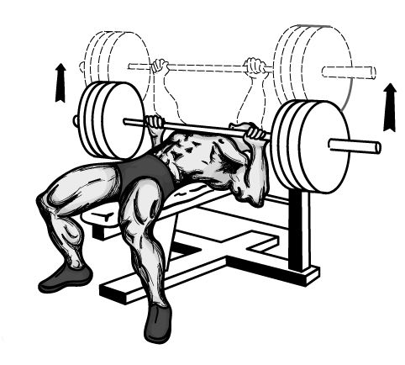
Muscular Strength
Amount of force that your muscles can exert against resistance.
(Max repps.)

Muscular Endurance
Ability of muscles to sustain repeated contractions against a resistance for an extended period of time. (15 + Repps)

Flexibility
Range of movement in joints, Length in muscles that cross the joints.

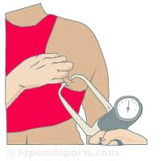
Body Composition
Fat and Fat free mass in the body. (Percentage of body fat)

